The Rusviet Union

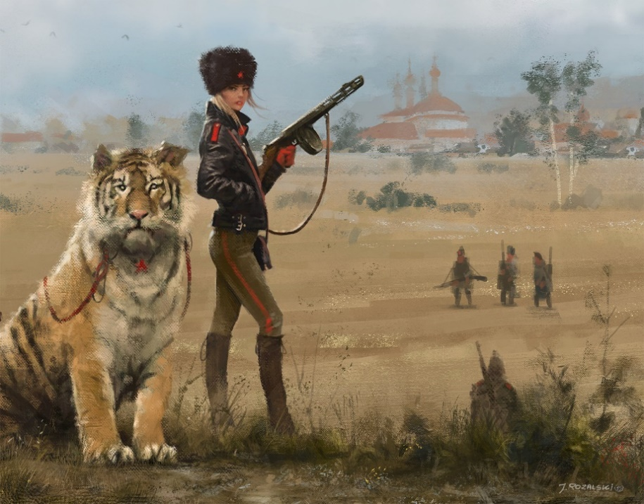

The Great War brought the once mighty Russian Empire to the brink of collapse, causing famine and a breakdown of authority. Bizarre political coalitions of liberals, communist revolutionaries, starving peasants, exploited factory workers, and mutinous soldiers rallied to oppose the war and the Tsarist Regime. Under the specter of a full-blown revolution, the Tsar begrudgingly accepted peace and abdicated much of his authority to a new democratic provisional government. The Liberal Democrats running the Union Provisional Government now must balance the needs of the Conservative Tsarists and the Communist Revolutionaries in order to prevent the outbreak of a Civil War. Every day of continued existence is a victory for the government.

Contents

The Rusviet Union Government 2
Rusviet Society & Culture 3
Rusviet Union Org Chart 4
Disagreements: Highlighted & Elaborated Upon 4
Map 6
From the Russian Empire to the Soviet Union: Actual History 6
Notable Differences between this Megagame, the 1920+ Universe, and History 10

The Rusviet Union Government

In the face of a full-scale country-wide revolution, the Tsar has abdicated most of his authority to a new, democratically elected provisional government. This provisional government is temporary by definition, only met to exist long enough to structure a new government.

While bickering about a new federal government, proponents of democracy have encouraged provincial and local authorities to spring up and assert influence over local administration. Originally intended to rapidly increase democracy in all parts of the country, the end result has been the rise of a number of contradicting governing bodies, sometimes extremist and sometimes anti-democratic.

As for how the actual government works, no one can really seem to articulate. On paper, the provisional government has lots of authority, but most Rusviets can’t read. Important questions concerning the status of the Monarchy, who directs foreign policy, property rights, and tax policies have yet to be determined.

Rusviet Society & Culture

Rusviet society is in chaos and the social order is rapidly breaking down under the strain of famine, war, and new radical social philosophies.

The Rusviet populace is mostly illiterate peasants who traditionally enjoyed little rights and abusive treatment by the noble class. Distrustful of the noble classes and the clergy, the peasants want bread first, and land reform second. It will take increased literacy or beyond-ordinary situations to further leverage the mass energy of a disgruntled people.

Conservative forces have rallied around the Tsar in an effort to protect their Tsar. The Eastern Orthodox Church and other privileged social classes have all traditionally depended on the Tsarist Regime for their authority. With no separation between the Eastern Orthodox Church and Tsarist government, the Tsar is considered to be ordained by God. Many conservative factions continue to treat the Tsar with extreme respect and reverence – regarding anti-Tsarist forces as anti-God.

In the cities, the spread of radical literature has empowered the abused dregs of society to begin organizing. Workers councils (called Soviets) and unions are emboldened by the recent liberal reforms but are dreaming of a world beyond the liberal capitalism of the West. Socialism and Communism now poll more popular than Capitalism among much of the urban youth.

Rusviet Union Org Chart

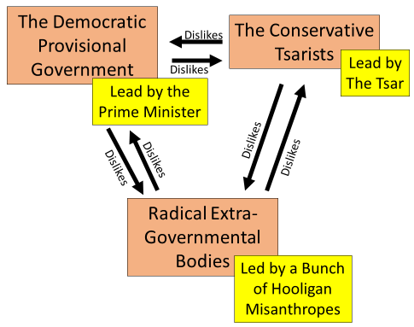

Disagreements: Highlighted & Elaborated Upon

Who’s in charge here? – Who does what in this new government is still ill-defined. This includes everything from who is responsible for making sure the trains run on time to who represents the country abroad.

Rural vs. Urban – While poor urban workers and poor peasant farmers have the same interests at heart (a better life for their families), governmental policies are often zero-sum. Rural agricultural subsidies cost money – money that could be spent on urban infrastructure.

The Monarchy – The Tsar has utterly lost the respect of the majority of Russians. However, many crucial forces still desire him to be exalted or given actual power. Does the Monarch belong in the new government?

Property Rights & Land Reform – Conservative forces would like to reinstate the serf system or otherwise support large landlord manors. Liberal forces would like to break up rural communes and large landlord manors in order to increase personally accountability to subsequently increase yields. Socialists support rural communes and hate landlords. Communists think the all land should belong to the state as a whole.

Peace, War, and Terror – Do the ends justify the means? And what means should we pursue? Strange bedfellows often disagree on tactics for gaining and maintaining power.

Toleration of extra-governmental groups – The democratic provisional government is in a tough spot. While these new groups of passionate young people are answering the call to decentralize authority in the Rusviet Union, many are espousing extremist and anti-government rhetoric.

Map

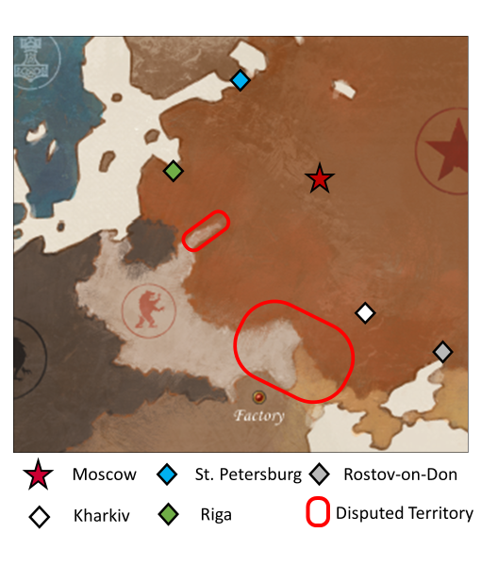

From the Russian Empire to the Soviet Union: Actual History

[After-Game Reading]

The late Russian Empire had three main factions vying for influence, the Tsarist Regime, the Intelligentsia, and the Peasantry.

The Tsarist Regime insisted on a rigid autocracy for the sake stability. Unconstrained by a constitution and with absolute and unlimited authority, the Tsar, his bureaucracy, his military, and his extensive secret police brutally suppressed political opposition and sources of internal disorder.

The Intelligentsia was actively cultivated by the Tsarist Regime in order to maintain the Empire’s prestige abroad. However, the lack of social opportunity in the government and society sustained a constant tension between the Intelligentsia and the Tsarists. Mostly liberal, often radical, the Intelligentsia was diverse but unalterably opposed to the status quo.

The Peasantry made up the 80% of Russian population. Most lived in rural communes which resisted the idea of private property. Instead, land was not owned individually and rights to manage the land was redistributed periodically to account for demographic changes. Since land ownership was a requirement for citizenship, no one in a commune had political power. Most urban workers were descendant of these rural communes (which were suffering from rural overpopulation), they brought the communal ideals into the cities.

The chronic mismanagement of the country by the Tsarist Regime and its leader, Tsar Nicolas II, led to the stunning and humiliated repeated defeats during the Russo-Japanese War and World War I. These humiliations along the extensive political oppression and a famine led to discontent and eventual revolution. Mass mutiny in the Army and political coup by democratic and communist factions forced Tsar Nicolas II to abdicate the throne in the 1917 ‘February Revolution’.

The Russian Provisional Government, led by socialist and liberal democratic factions but also populated with communists and radicals, officially assumed the mantle of government but was largely swallowed in the chaos consuming the country. A second rivaling government body, The Petrograd Soviet, emerged in the chaos, resulting in a brief ‘Dual Powers’ period in the Russian Revolution.

The Petrograd Soviet, led by the radical fanatic, Vladimir Lenin, eventually declared the Russian Provisional Government as bourgeoise and overthrew it, leading to the prolonged and bloody period of Civil War throughout Eastern Europe. Lenin and later Joseph Stalin’s unique breed of authoritarian communism rejected the rural commune philosophies, which resembled primitive anarchy more than the collectivized, authoritarian communist system which developed. Ironically, both the Tsarist Regimes and the Soviet Union displayed a remarkable disregard for the lives of peasants, which made up the majority of their power base.

Largely forgotten are the number of less radical revolutionary factions which existed in Revolutionary Russia but were politically outmaneuvered or brutally suppressed by Lenin’s specific communist faction, the Bolsheviks. The conservative liberal Octerborists and KaDets, as well as the socialist democratic Trudoviks were declared bourgeoise and suppressed. The initially influential Minority Labor Bloc faded away as minorities throughout the country became viewed as anti-revolutionary. Large, communal peasant revolts plagued the Revolutionary period but were suppressed. Lenin himself politically outmaneuvered several sub-factions of the larger Socialist Revolutionary party, eventually leaving his Bolshevik faction as the ‘last man standing’. The last existing anti-Bolshevik ‘White’ factions Russian Civil War included some monarchists, but many more democrats, liberals, and socialists resistant to state collectivization of property and growing authoritarian government. These less-radical factions represented Russia’s last chance at any semblance of democracy or self-determination until the collapse of the Soviet Union in 1991.

Lenin’s personal communist ideology thoroughly influenced the development of the Soviet Union government and society. Lenin disagreed with the traditional communist narrative originally espoused by Marx. While Marx had declared that a large industrial base and an existing capitalist system were required in order for society to voluntarily choose communism, Lenin posited that certain moments in history present opportunities to skip this period of capitalism and jump straight to communism. In other words, even though Russia was large, poor, undeveloped, and illiterate, conditions were so bad that communism could succeed if implemented correctly.

And logically, since Russia was so large, poor, undeveloped, and illiterate; massive, radical, top-down change was required in order for the communist system to work. This solicited the growth of a large, all-encompassing federal bureaucratic regime and the nation-wide confiscation of all private and communally-shared property, contradicting the ideals of many socialist and communist thinkers who bled for the revolution. In total, the phrase ‘the end justifies the means’ can be aptly applied to Lenin’s brand of communist ideology and the subsequent authoritarian government.

Joseph Stalin and later Soviet leaders would also embody this philosophy and declare themselves as ‘Protectors of the Revolution’ as they brutally suppressed internal dissent and killed millions. While quantifying the victims can be near-impossible, Russian scholar, Aleksandr Solzhenitsyn, estimates a total of 66,700,000 people became victims to state repression and terrorism from 1917–1959. This include deaths but also those arrested, sent to psychiatric hospitals, work camps, or gulags, expelled from their work or the country, or involved in often-fatal forced migration efforts.

Notable Differences between this Megagame, the 1920+ Universe, and History

- The 1920+ Universe does not characterize the Rusviet Union very much. ‘Rusviet’ rhymes with ‘Soviet’, and sources have alluded to the Tsar still being alive in the 1920+ Universe. These two pieces of evidence suggest that the Rusviet Union is based off of the very early Soviet Union (after provisional government collapsed but before the murder of Tsar Nicolas II and his family). The megagame is instead based slightly earlier during the brief period of the Russian Provisional Government.
- The true brutality of the Tsarist and Soviet Regimes is largely not elaborated on in this megagame. This is a purposeful design decision to make players more comfortable. It is the opinion of the designer is that these types of geopolitical simulations can act as powerful educational tools and that a ‘whitewashing’ of atrocious regimes for the purpose of these events can led to players learning more about just how evil, banal, ideologically motivated, and human these regimes are.

